 About education

Typical Education Services
Occasional Paper D-12 January20, 2020

An education system is an array of programs and services put in place by a community to encourage and support the education of its citizens; support is usually focused on (1) helping individual citizens gain skills, knowledge, attitudes and values that help them thrive in the years ahead and (2) providing human resources needed to maintain the community as a place people want to live. Typically, education functions or services include:
1. Governance – decision making processes put in place to structure, and regulate actions 2. Leadership – process of motivating a group of people to achieve a common goal.
- Funding - providing resources to meet educational needs
- Regulation – make rules, laws and policies
- Information – current and dependable information as the basis of making decisions
- Counselling – providing help, advice and a course of action
- Instruction – providing information, lectures, presentations, sampled and models of and understanding in systemic way.
- Quality assurance - the maintenance of a desired level of quality in a service or product,
- Learning products – materials and devices available to assist teachers and learners to acquire new knowledge, skills and attitudes.
- Human resources – people with skills and attributes available to provide services to the education sector

(A schematic of these services is provided on the reverse of this page)

The PEI Department of Education and Lifelong learning gives its role as one of developing and delivering “high quality programs and curriculum in English and French to Island children from birth to Grade 12.” ; that is a narrow a vision of education and of education services for the year 2020. Other services in the “education toolbox” are shown above. It’s time to dust them off, sharpen them up, and make them available to Islanders. To increase the impact of the additional, services, the Department is urged to first review and update founding principles, adopt a “learner-centered” approach to instruction, adopt the OECD recommendation for more autonomy in schools, and increase general accountability throughout the system.

Our learner deserve nothing less.

Don Glendenning

The above article represents the views of the writer and not Education 20/20 Inc.

Education 20/20 Inc. 101 Kent St., PO Box 624/rue Kent, BP 624 Charlottetown, PEI C1A 1M0 Canada
Tel: 902-892-2060; Email: pei@education2020.ca; www.education2020.ca

TYPICAL EDUCATION SERVICES


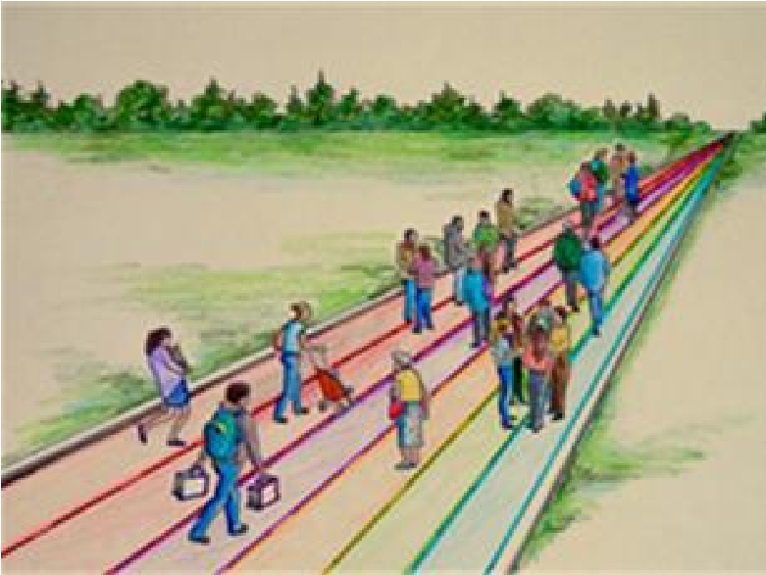
INFO & COUNSELLING:

Islanders on the road of life

Education system
-

services

put in place by a community

to encourage and support

the education of its citizens

Education 20/20 Inc.

PO Box 624 / 101, rue Kent

Charlottetown (Î.
-
P.
-
É.)
C1A 1M0

Email/Courriel:
pei@education2020.ca

URL: www.education2020
^{.ca}

GOVERNANCE & LEADERSHIP Information
Leadership Counselling
Planning Assessment
Liaison Diagnosis
Support Referral
Research Advocacy
Advocacy Promotion
Quality Control ?
?

INSTRUCTION HUMAN RESOURCES
Presentation Teachers
Demonstration Administrator Practice Teacher Advisors
^{Diagnosis} Teaching Assistants
Instructional materials Specialists
^{Liaison} Guidance Counsellors Coaching ? Record keeping
Guided Practice LEARNING PRODUCTS
? Texts and
References,
Self-instructional material
Assistive technologies
QUALITY ASSURANCE Internet
Credential Software Qualification MOOCS
Proficiency Technology
Level ?
? FUNDING
Capital
Operating
Transportation

